DRAFT New title to be released in Fall 2014

The Simmering Cauldron: High Stakes in the North Caucasus
The Russian Winter Olympic Games to be held in Sochi, Russia’s top resort, on the Black Sea in February 2014, will focus international attention on the North Caucasus, a region the Western media have overlooked in their reporting on Russia. The Kremlin hopes the event will highlight the country’s status as a major international power, but under the surface another reality impinges, one headlined by frequent terrorist acts of violence spreading outward from Chechnya for several years. And an hour’s drive down the coast Russian forces occupy Abkhazia and South Ossetia, Georgia, a new alignment of forces, the result of its 2008 war with Georgia, hardly a halcyon setting for a global PR event.
The Simmering Cauldron will take the reader inside the North Caucasus today.
The Islamic terrorist threat is ever present. In February 2011 during a visit to the Olympic facilities by Russia’s then President Dmitri Medvedev and then Prime Minister Vladimir Putin a series of attacks took place in Kabardino-Balkaria, a few hundred miles from Sochi, in the Russian North Caucasus, in which tourists from Moscow were among those killed; a funicular on Mount Elbrus was damaged, acts inflicted by a terrorist group linked to the Emirate of Caucasus group. Since 2007 the situation has been deteriorating: Chechnya, Dagestan and Ingushetia are war zones pitting Russia special forces against militants, with a constant threat of terrorism including in Kabardino-Balkaria.
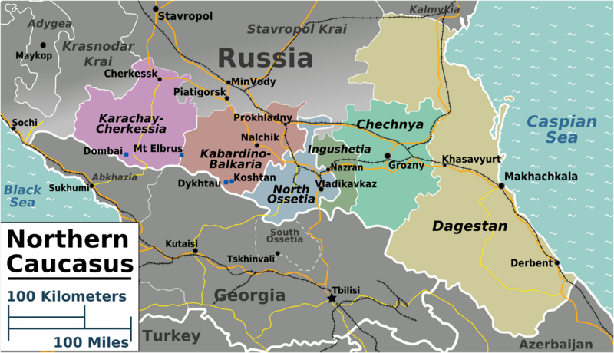
Map of the North Caucasus
When Putin opted to hold the Sochi Games in 2005 the Kremlin believed it had quelled terrorism in this volatile region. Russia’s two brutal wars in Chechnya, which included dispatching military, police and security forces in mop up operations during the second Chechen war in 1999-2000, exercised a cruel toll: millions living in poverty, up to half a million refugees and internally displaced persons, mostly ethnic Russians, a destroyed infrastructure and the rise of an Islamic insurgency. Far from solving the situation, Russia’s heavy handed and misguided policies created a simmering cauldron of mistrust and resentment.

The reality -- the situation is getting worse in Chechnya, not better, under the Kremlin’s appointee, the henchman Ramzan Kadyrov. With Moscow’s backing, this former warlord has established a Shariah-tinged absolutist regime, a medieval fiefdom, in Chechnya. His brutal crackdown on Islamist terrorist groups has encouraged the spread of militancy to other parts of the North Caucasus. In this light it is hard to see how the Sochi Games will be free of tension.

Russia’s choice of staging the Olympic Games in Sochi has several strategic and geopolitical aims including reasserting control over the Caucasus. It is a colonial war reminiscent of Russia’s 300 year conquest of the Caucasus. In this quest for federal control Moscow is applying a political strategy of balancing the Slavic majority Orthodox Christians of the Northwest Caucasus -- including the sizeable Cossacks populations -- in Stavropol and Krasnodar regions, against the northeast, what are today the 100% Islamic regions of Chechnya, Ingushetia and Dagestan.

The North Caucasus is increasingly politically beyond the reach of the Kremlin. The implications are huge on a number of levels: terrorism has spilled over into Russia. Events in the North Caucasus cannot be separated from the South Caucasus or Central Asia. Another factor looming large in the pantheon of security threats is the US withdrawal from Afghanistan in 2014 which could bring huge problems, such as drug smuggling, the spread of terrorism and Islamic fundamentalism from Afghanistan into Central Asia, with terrorist groups linking up with militants in the North Caucasus.
What is needed if there is any chance to win back the peoples of the region is for Russia’s political system to modernize itself, to establish the rule of law and judicial reform, which it is incapable of doing, as the current goal of Russia’s elite is untrammelled self-enrichment, absent a vision of national economic development and democracy, of systemic change. Many of the reasons driving people to extremism in the North Caucasus are poverty and unemployment, poor governance, the absence of rule of law, a corrupt police. The modernizing of Russia’s political institutions and respect for human rights would bring an end to the billion of dollars in subsidies from the Kremlin to the ruthless and reckless Kadyrov, a point of growing resentment by the Russian public, and would open a Pandora’s box. But it is difficult to see another way forward.
In the meantime, the Sochi Games, are an expensive US$51 bn spectacle, a Potemkin village masking a simmering cauldron.
_____

